Membrane Structure and Function
How do substances move in and out of cells?

Model 1: The Fluid Mosaic Model

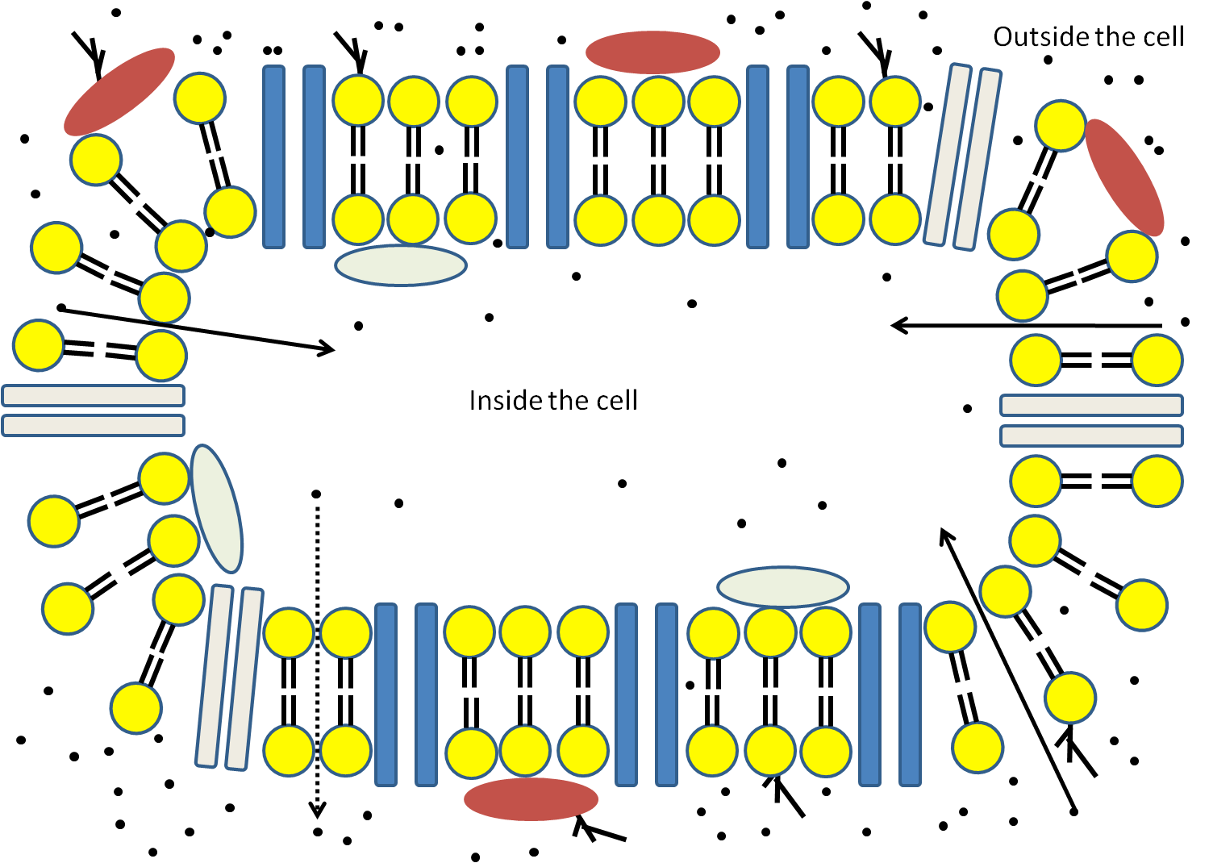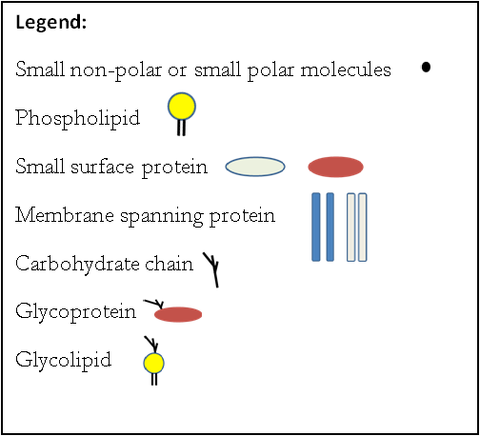

- How many types of protein molecules are found in the model?

- What is the difference between the surface proteins and the membrane spanning proteins?

- What are the two major types of biological molecules that compose the fluid mosaic model?

- When a carbohydrate chain is attached to a protein what is the structure called?

- When a carbohydrate is attached to a phospholipid what is the structure called?

- What types of molecules appear to be moving across the membrane?

- With your group list as many examples as you can of small polar and small non-polar molecules that may be involved in moving across cell membranes.

14. Where exactly in the membrane do these molecules pass through?
- How does the concentration of the small molecules inside the cell compare to that outside the cell?

- Because of the random movement of molecules they tend to move across the membrane in both directions. Do the molecules appear to move equally in both directions? Justify your answer using complete sentences.

- Using all the information from the previous questions complete the passage below:

Diffusion is the movement of molecules from an area of concentration to an area of concentration. The molecules will continue to move along this concentration gradient until they reach equilibrium. In cells, small molecules, such as water and small - molecules such as and move by across the cell membrane.

