Cellular respiration notes

- Cellular Respiration: Release of the energy stored in food.
- ATP: Useable form of energy
- Glycolysis: first step in aerobic or anaerobic respiration.
- Anaerobic: without oxygen
- Aerobic: with oxygen
- Oxidation: Reaction when an atom or molecule loses electrons
- Reduction: Reaction when an atom or molecule gains electrons,
- Fermentation: Glycolysis is followed by the conversion of pyruvic acid into some end product with no further release of energy
- Kreb’s Cycle:Continuing series of reactions
- Electron Transport Chain: reaction within the mitochondrion that powers the formation of ATP.

Hydrogen (Electron) Acceptors

- Recall: Oxidation and Reduction
- After complex carbs are broken down into glucose, glucose is broken down in a biochemical pathway. Oxidation and reduction take place along the way.
- NAD (nicotinamide adenine dinucleotide) and FAD (flavine adenine dinucleotide) are electron carriers (or acceptors)
- NAD and FAD c an each accept a pair of high-energy electrons and a proton, becoming reduced.
- After accepting high-energy electrons, molecules gain energy temporarily
Glycolysis

- Occurs in cytoplasm of the cell
- Is the first step in both aerobic and anaerobic respiration
- In this step, glucose is split.
2 phosphate groups are bonded to a glucose molecule. This uses 2 molecules of ATP.
- A group of chemical reactions break down the glucose molecule into 2 molecules of pyruvic acid. This produces 4 molecules of ATP.
- The net result is thus 2 molecules of ATP for every glucose. Also, 2 molecules of NADH are formed.
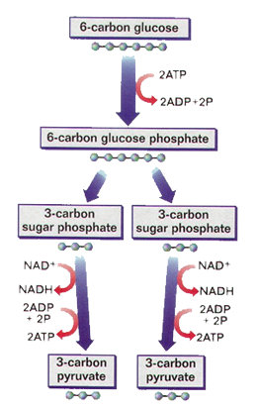

Fermentation

- In anaerobic respiration, glycolysis is followed by a conversion of pyruvic acid into some end product with no further release of energy (no more ATP formed)
- This is called fermentation
- Examples: In plant cells, the end result is ethyl alcohol. In animal cells, it is lactic acid.

- In fermentation, pyruvic acid acts as an electron acceptor. They get these electrons from NADH, which is then ready as NAD to be used again.

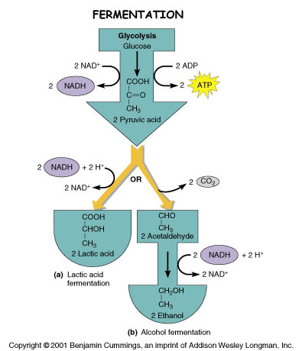

Aerobic Respiration
- The use of oxygen in the breakdown of food substances allows the cell to release far more energy.
- Aerobic respiration begins with glycolysis. The rest of the steps take place within the mitochondria.
- Inside the mitochondrion, pyruvic acid breaks down into CO2 NADH, and a 2-carbon compound. This compound, combined with coenzyme A, forms acetyl CoA.

Krebs Cycle

- Named for Sir Hans Krebs
- Acetyl CoA begins the Krebs Cycle, which is a continuing series of reactions
- Each turn of the Krebs Cycle takes one molecule of Acetyl CoA and converts it to 2 molecules of CO2, 3 molecules of NADH, 1 molecule of FADH2.
- Only 1 molecule of ATP is produced by each turn.

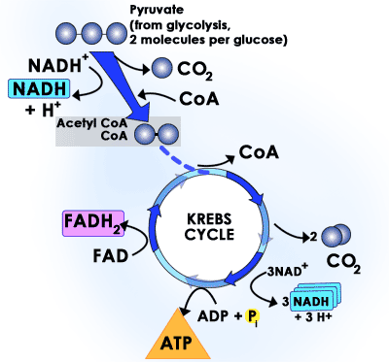

Electron Transport Chain

- Most of the energy released by breaking down glucose comes through the electron transport chain.
- This is a highly organized system of enzymes and coenzymes on the inner membrane of the mitochondrion.
- NADH and FADH2 carry electrons into the chain and pass them from one compound to another. Eventually, oxygen is the final acceptor.
- At various points, energy is given up and used to pump hydrogen ions across the mitchondrial membrane.
- This creates an electrical gradient, which provides the energy to convert ADP to ATP

- In glycolysis, one molecule of glucose forms 2 molecules of ATP.
- In the Krebs cycle, 2 more molecules of ATP are formed (1 for each pyruvic acid)
- In the Electron Transport Chain, 32 molecules of ATP are formed from each glucose molecule.
- Therefore, each glucose molecule yields 36 ATP molecules.

- The net reaction is:
C₆H₁₂O₆ + 6O₂ → 6CO₂ + 6H₂O + Energy (36 ATP)

