Light Reactions
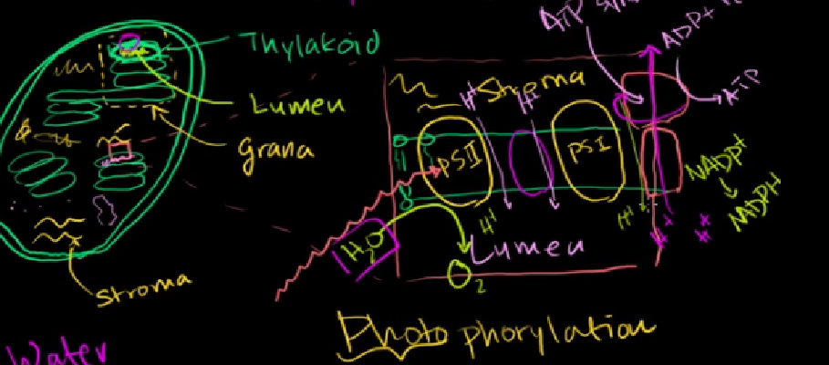
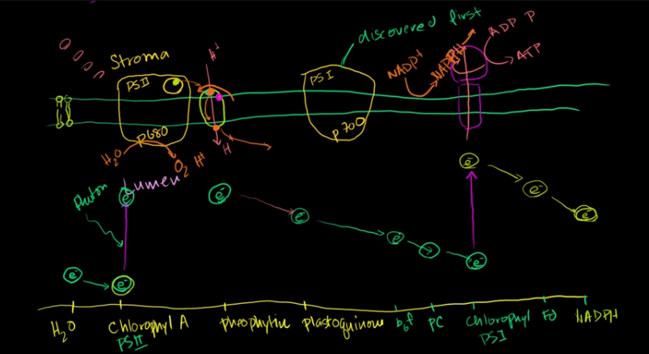
Dark Reactions – The Kelvin Cycle (phosphoglyceraldyhyde) – enzyme rubisco
