# *Elements & Macromolecules in Organisms*



# The four main classes of organic compounds (carbohydrates, lipids, proteins, and nucleic acids) that are essential to the proper functioning of all living things are known as polymers or macromolecules. All of these compounds are built primarily of carbon, hydrogen, and oxygen but in different ratios. This gives each compound different properties. All organic compounds contain carbon. *Color code* the Carbohydrate on this worksheet (carbon-black, hydrogen-yellow, nitrogen-blue, and oxygen-red).

**O**

**C**

**C**

**C**

**C**

**C**

**O**

**H**

**H**

**C**

**H**

**H**

**O**

**H**

**H**

**H**

**O**

**H**

**H**

**O**

**H**

**H**

**O**

**H**

# 1. If all the macromolecules are made mainly of the elements C,H,O, how are they different.

# These molecules are all different because of the different ratios of C:H:O.

# 2. How could you tell the image above is a carbohydrate from its structure?

# Carbohydrates all have a ratio of 1:2:1 for their C:H:O ratio, the 5 carbon ring seen above is also a notable characteristic of simple sugars.

# *Color code* the amino acid on this worksheet (carbon-black, hydrogen-yellow, nitrogen-blue, and oxygen-red).

# Basic Structure of Amino acid

**N**

**H**

**H**

**C**

**C**

**O**

**H**

**H**

**R group**

# 3. Chains of amino acids make Polymers/peptides which can join together to make a Protiens.

# 4. How can you easily tell if you are looking at an amino acid from its structure?

# Amino acids will all have the basic structure seen above, with a single nitrogen on one side and a carboxyl group (O—C –H ). The R group is what changes to create the different amino acids.

# *Color* the glycerol molecule using the same colors for carbon, hydrogen, and oxygen as you did before. The fatty acid chains may be saturated (only single bonds between carbons) or unsaturated (contain at least one double bond). A carboxyl functional group (-COOH) is found on the end of the fatty acid that does NOT attach to glycerol. *CIRCLE AND LABEL* the carboxyl groups in the 2 fatty acids on this worksheet. *Color* the fatty acid chains the same colors for carbon, hydrogen, and oxygen as you did before. A special type of lipid called phospholipids help make up the cell membrane. Two layers of these phospholipids make up the membrane. Phospholipids have a "water-loving" hydrophilic head and two "water-fearing" hydrophobic tails. *Find* the cell membrane on this sheet and *CIRCLE AND LABEL* a phospholipid. Proteins are also embedded in the cell membrane. *Color* the two proteins in the cell membrane blue. Glycerol

**C**

**C**

**C**

**H**

**H**

**H**

**H**

**H**

**O**

**O**

**O**

**H**

**H**

**H**

# Saturated fatty Acid

**H**

**C**

**C**

**C**

**C**

**C**

**C**

**H**

**C**

**C**

**C**

**H**

**H**

**H**

**H**

**H**



**H**

**H**

**H**

**H**

**H**

**H**

**H**

**H**

**H**

**H**

**H**

**H**

**C**

**O**

**O**

**H**

# Unsaturated Fatty Acid - Double Bond

**H**

**C**

**C**

**C**

**C**

**C**

**C**

**H**

**C**

**C**

**C**

**H**

**H**

**H**

**H**

**H**



**H**

**H**

**H**

**H**

**H**

**H**

**H**

**H**

**H**

**H**

**H**

**H**

**C**

**O**

**O**

**H**

# Cell Membrane

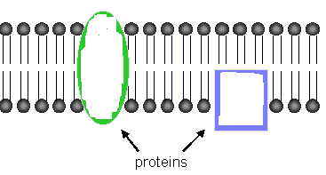

# *Questions:*

# 5. Lipids are nonpolar. What does this mean?

# Non-polar means that there is no charge across the molecule. Polar molecules will have one side that is slightly positive and one side that is slightly negative.

# 6. If there are all SINGLE bonds between Carbons in the fatty acid chain, then it is said to be Saturated_.

# 7. If there is a DOUBLE bond between Carbons in the fatty acid chain, then it is said to be Unsaturated.

# 8. The head of a phospholipid is Water loving and is said to be Hydrophilic.

# 9. The 2 tails of a phospholipid Fear water and is said to be Hydrophobic.

# Nucleic acids carry the genetic information in a cell. DNA or deoxyribose nucleic acid contains all the instructions for making every protein needed by a living thing. RNA copies and transfers this genetic information so that proteins can be made. The subunits that make up nucleic acids are called nucleotides.

# *COLOR AND LABEL* the parts of a nucleotide --- sugar (5-sided)-green, phosphate group (round)-yellow, and nitrogen base (6-sided)-blue. ATP used for cellular energy is a high energy nucleotide with three phosphate groups. *Color* code the ATP and LABEL THE PHOSPHATES.

# Nucleotide

# ATP

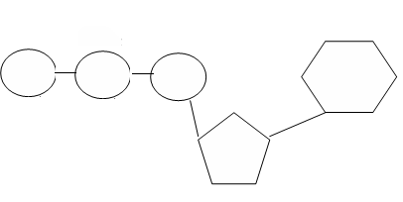

# *Questions:*

# 10. The nucleic acid RNA copies DNA so Proteins can be made.

# 11. The 3 parts of a nucleotide are a 5 carbon Sugar, a phosphate, and a nitrogen Base.

# 12. ATP is a high energy molecule made from a Nucleotide with 3 phosphates.